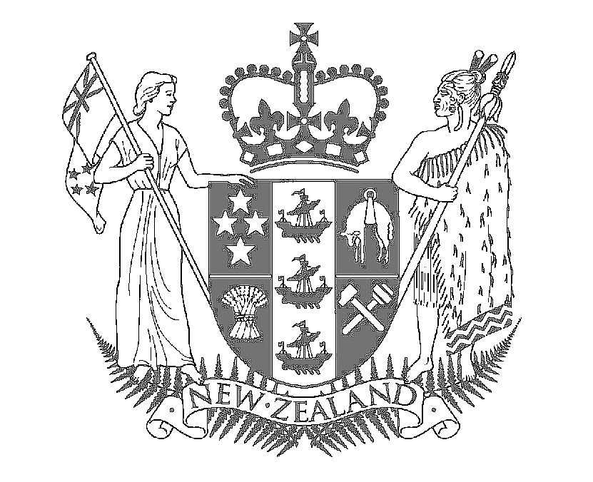
Speech Notes

HON MAHARA OKEROA
Associate Minister for Arts, Culture and Heritage

2007 Arts Pasifika Awards

Auckland War Memorial Museum Event Centre
12 November 2007

Talofa lava (Samoa), Kia orana koutou, katoatoa (Cook Island), Taloha ni (Tokelau), Malo e lelei (Tonga), Fakaalofa lahi atu (Niue), Talofa (Tuvalu), Ni sa bula vinaka (Fiji), Ia orana (Tahiti), Gud de tru (Melanesian)

I bring warm pacific greetings from our Prime Minister – Rt Hon Helen Clark and newly appointed Minister for Pacific Island Affairs – Hon Luamanuvao Winnie Laban.

Anton thank you for your warm introduction.

I would also like to acknowledge:
- Reverend Suamalie Iosefa for your opening words
- Pele Walker
- Albert (Whiti) Wendt
- Award nominees
- Special guests, community leaders and elders
- Ladies and gentlemen

It is a tremendous pleasure to be a part of this evenings Arts Pasifika ceremony and to see so many people here to celebrate the achievements of the six award recipients.
The richness and diversity of Pacific arts is an important part of Aotearoa growing international profile as a creative nation.

Pacific Artists are making a major contribution to Aotearoa artistic landscape and the development of Pacific Arts and Artists is at an exciting crossroads.
The art works of Pacific artists based in Aotearoa interpret the worlds and stories of Pacific nations, but these are uniquely filtered through the artists’ experience of living in Aotearoa.

In both traditional and modified forms, Pacific art and cultural practices help make New Zealand different from any other nation. Pacific and Mäori arts and the collaboration between them are giving New Zealand a strong point of difference on the world stage.
Pacific motifs have been incorporated into our cultural landscape, and are now part of all our cultural identities.

The ways in which we are expressing ourselves, in all art forms, is changing over time.
So many young, emerging artists – doing it their way, with contemporary tools, in electronic and digital media – have helped establish the rights of Pacific Islanders to speak for their own cultures and for Aotearoa as a creative nation in the 21st century.

Technology and expanding opportunities for travel and cultural exchange are transforming our worlds and our futures.
The downside of this cultural exchange is the world-wide spread of dominant cultural trends.
In such a context, however, distinctiveness is increasingly valued, and Pacific artists are enjoying great success internationally.

Art reflects on the society that produces it. The current strength and vitality of our art forms are a celebration of who we are, and make us stronger as a nation.
The arts provide a sense of and source of history, role, identity and pride. The arts are also an effective mechanism for cross-cultural dialogue.

Through the arts the broader New Zealand community and increasingly, the international community, are able to gain a better understanding of the life and cultures of New Zealanders of Pacific Island heritage.
My congratulations to all the nominees and winners tonight for the future of indigenous cultures are looking very bright in the hands of our artists.

